**Course Methods Year 12 test three 2022**

Student name: ________________ Teacher name: ________________

**Task type: Response**

**Time allowed for this task: _____40______ mins**

**Number of questions: ____6_______**

**Materials required: Upto 3 calculators/classpads allowed**

Standard items: Pens (blue/black preferred), pencils (including coloured), sharpener, correction fluid/tape, eraser, ruler, highlighters

Special items: Drawing instruments, templates, **one page of A4 notes doublesided**

**Marks available: ___43___ marks**

**Task weighting: _10___%**

**Formula sheet provided: Yes**

**Note: All part questions worth more than 2 marks require working to obtain full marks.**

Q1 (3, 3 & 2 = 8 marks)

Consider the discrete random variable  and the table of probabilities below.

|  |  |  |  |  |  |
| --- | --- | --- | --- | --- | --- |
|  | 0 | 1 | 2 | 3 | 4 |
|  | 0.2 |  | 0.3 |  | 0.25 |

1. Given that the expected value of  is 2.15, determine the values of .

|  |
| --- |
| **Solution** |
|  |
| **Specific behaviours** |
| 🗸 sets up one equation for a & b  🗸 sets up two equations for a&b  🗸 solves for a&b |

1. Determine the standard deviation of to 3 dp, showing all reasoning.

|  |
| --- |
| **Solution** |
|  |
| **Specific behaviours** |
| 🗸 shows a sequence for variance  🗸 determines variance  🗸 determines std to 3 dp |

1. Determine the  and Variance().

|  |
| --- |
| **Solution** |
| Variance(). |
| **Specific behaviours** |
| 🗸 determines new mean  🗸 determines new Variance |

Q2 (3, 2, 1 & 3 = 9 marks)

The number of  minutes late a train arrives at a particular station is a uniform probability distribution from 5 mins to 25 mins.

1. Sketch the probability density function for  showing all relevant features and labels.

|  |
| --- |
| **Solution** |
|  |
| **Specific behaviours** |
| 🗸 uses straight line  🗸 x labels  🗸 y label |

Q2 continued

1. Determine the probability that the train will be less than 12 mins late given that it is at least 7 mins late.

|  |
| --- |
| **Solution** |
|  |
| **Specific behaviours** |
| 🗸 correct denominator  🗸 correct numerator |

1. Determine the mean number of minutes late.

|  |
| --- |
| **Solution** |
| Mean = 15 mins |
| **Specific behaviours** |
| 🗸 states midpoint |

1. Determine the standard deviation of  showing all reasoning.

|  |
| --- |
| **Solution** |
|  |
| **Specific behaviours** |
| 🗸 sets up integral  🗸 determines variance  🗸 determines stdev |

Q3 (3, 3 & 2 = 8 marks)

Consider a game where two ordinary dice are thrown into the air and then land and the sum of the two top numbers is added. If the sum is a prime number  etc then this is considered a win.

1. Determine the probability of a win. Show reasoning.

|  |
| --- |
| **Solution** |
| |  |  |  |  |  |  |  | | --- | --- | --- | --- | --- | --- | --- | |  | 1 | 2 | 3 | 4 | 5 | 6 | | 1 | 2 | 3 | 4 | 5 | 6 | 7 | | 2 | 3 | 4 | 5 | 6 | 7 | 8 | | 3 | 4 | 5 | 6 | 7 | 8 | 9 | | 4 | 5 | 6 | 7 | 8 | 9 | 10 | | 5 | 6 | 7 | 8 | 9 | 10 | 11 | | 6 | 7 | 8 | 9 | 10 | 11 | 12 |   Prime numbers 2,3,5,7,11  Pr(prime)=15/36 |
| **Specific behaviours** |
| 🗸 shows sample space  🗸 number of favourable outcomes shown  🗸 states probability |

1. If this game was played 10 times, determine the probability that a win occurs at least 7 times. Show all reasoning.

|  |
| --- |
| **Solution** |
|  |
| **Specific behaviours** |
| 🗸 states Binomial with parameters  🗸 uses cumulative expression  🗸 states prob |

1. Let  = sum of the top numbers of both dice. Determine the mean and standard deviation for .

|  |
| --- |
| **Solution** |
|  |
| **Specific behaviours** |
| 🗸 states mean of 7  🗸 states stdev 0f 2.415 |

Q4) (5 marks)

Consider  where  are constants.

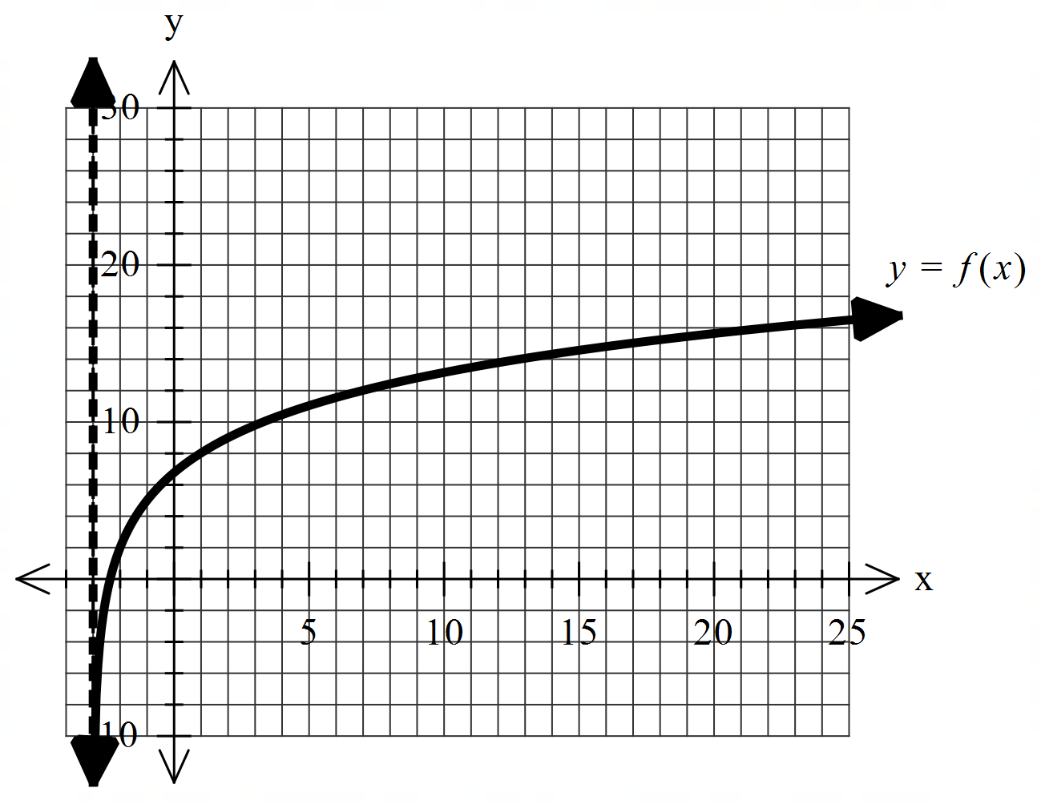

Using the graph above and given that the following points

 lie on the curve , determine the values of .

|  |
| --- |
| **Solution** |
| Asymptote x=-3, p=3 |
| **Specific behaviours** |
| 🗸 identifies asymptote at x=-3  🗸 determines p  🗸 sets up one equation with two unknowns  🗸 sets up two equations with two unknowns  🗸states r & q |

Q5 (2, 2 & 2 = 6 marks)

Consider the probability density function  and zero for all other values

of .

1. Show that .

|  |
| --- |
| **Solution** |
|  |
| **Specific behaviours** |
| 🗸 sets up integral for total area =1  🗸 shows equation to solve for a |

1. Determine the probability  for the above function.

|  |
| --- |
| **Solution** |
|  |
| **Specific behaviours** |
| 🗸 numerator  🗸 denominator |

1. Determine the median.

|  |
| --- |
| **Solution** |
|  |
| **Specific behaviours** |
| 🗸 sets up equation for median  🗸 states one median only |

Q6 (2 & 5 = 7 marks)

1. Show **without the use of a classpad** how to .

|  |
| --- |
| **Solution** |
|  |
| **Specific behaviours** |
| 🗸 uses product rule  🗸 obtains correct expression |

1. Using (a) above and **without the use of a classpad**, show how to evaluate .

Hint-use 

|  |
| --- |
| **Solution** |
| **Note- zero marks if answer given without any working!** |
| **Specific behaviours** |
| 🗸 integrates expression from part a  🗸 uses FTC  🗸 changes  and shows integration of these two terms (or uses u=3x+1)du  🗸 evaluates x=0 and x=1 showing both values for two terms after integration  🗸changes factor to give required definite integral(no need to simplify) |